OoliteStarter Retry
User Interface Brainstorming
This document contains concept drawings of new OoliteStarter user interface.
It is intended to be a base for discussion.

Guidance taken from FlightGear:
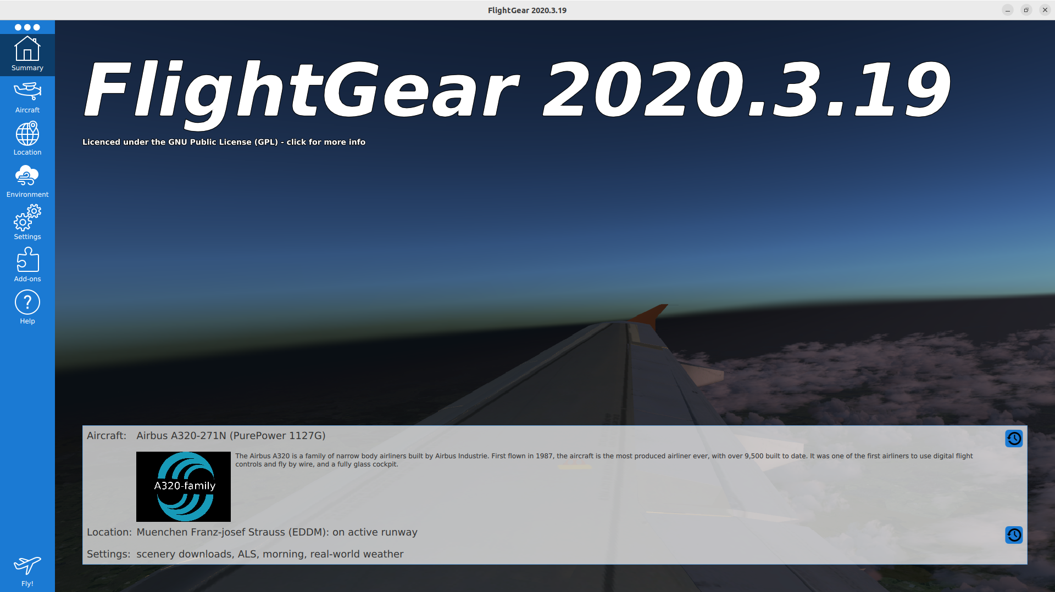
This entry UI was added to the simulator after the project had matured quite well. It’s purpose is to make it easy for users to run the simulator without having to learn lots of command line parameters.
Users can choose their configuration (install/uninstall/select aircraft, location on planet, weather conditions, etc) or reconfigure the simulation setup before finally diving into the simulated world (the fly button in the bottom left).
OoliteStarter’s purpose is quite similar.

Summary (Entry page)
When OoliteStarter is run, it will present itself with an entry page.
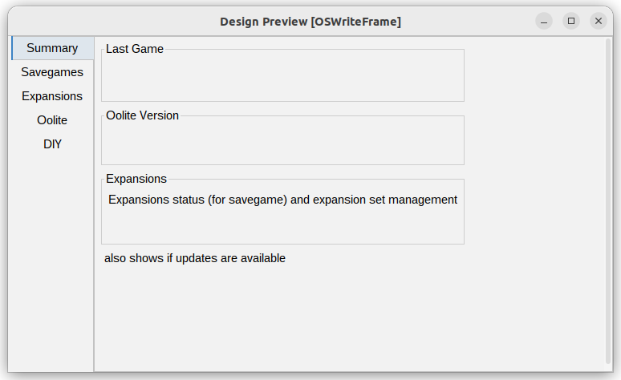
The purpose is to give a quick overview of settings that would allow a pilot to quickly resume his gaming experience, while still presenting crucial information about completeness of the installed OXPs or availability of updates – be it on Oolite or on expansions alike.

Savegames
This page allows pilots to manage their savegames. This usually would end up in CRUD functionality, although…
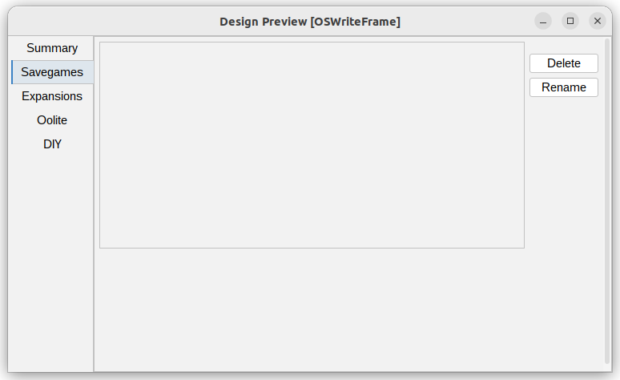
Creating savegames is done from within Oolite
Reading savegames means the list and detail view of a selected game.
Updating savegames is done from within Oolite (should backup/versioning be available?)
Deleting savegames needs to be available here
Rename may come in handy as it does not exist elsewhere

Expansions
The expansions view allows a user to understand available and installed expansions – be them OXPs or OXZs.
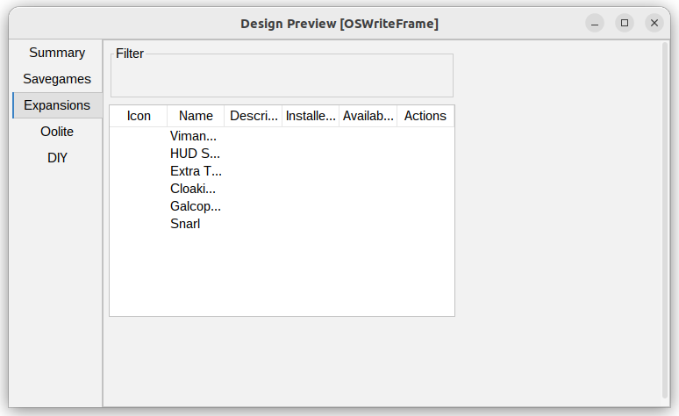
This screen might be similar to what we have but the screen layout would be cleaner.
The disabled/enabled functionality might be available for expert mode.

Oolite
This screen allows to manage the installed/active Oolite version.
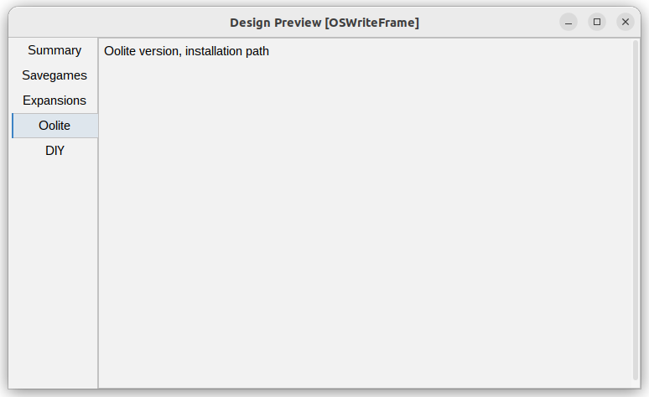
There would be support for one version at a time, unless expert mode is chosen.

DIY
Some hacking support/starter for new OXPs could be given here such that users find an easier start.
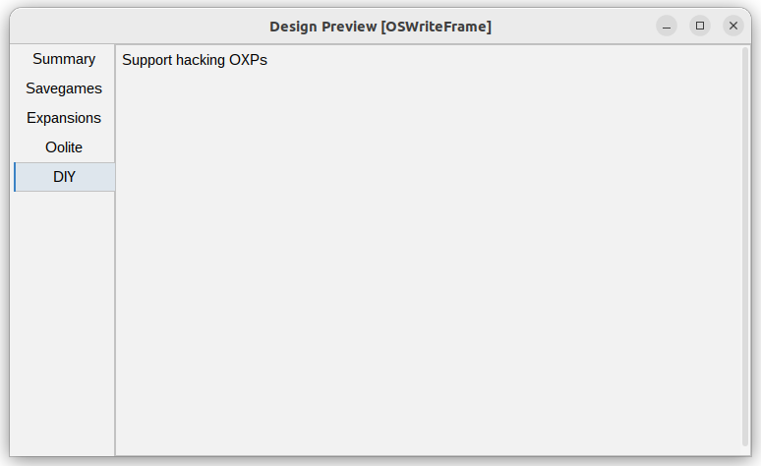
This whole screen may be hidden unless expert mode is shown

Gimmicks
While Oolite is running, OoliteStarter jumps to the background. If reactivated (it is reactivatable for users) it will show a wait screen.
Regardless of the wait screen – Mr Gimlet can give further advice to the user without using modal popup boxes that interrupt the user’s flow. This allows the application to give hints without annoying the user.

